

Project Increment -1

Tech Roos Team(Aditya Deshpande, Rakesh Reddy Kondakindi,Tej Kiran Meka,Girish babu)

**Detail Design of Services:**

**Registration:**

**Class Diagram:**



**Sequence Diagram:**



**Login:**

**Class Diagram:**



**Sequence Diagram:**



**Implementation:**

In first Increment we want to create login and registration services for donors and organizations.

**Database:**

We created a database with the following tables:

**Table 1:**

**Name: Registration**

In this table details of the donor's will be saved after the registration process.

There are

* **FirstName (string):**

First name entered by the donor will be stored.

* **LastName (string):**

Last name entered by the donor will be stored.

* **EmailId (string):**

Email Id entered by the donor will be stored.

* **Password (string):**

Password entered by the donor will be stored.

* **DOB (int):**

Date of Birth of the donor will be stored.

* **Gender (string):**

Gender of the donor will be stored.

**Table 2:**

**Name: Organization_Registration**

In this table details of the organization will be stored after registration process.

**Name (string):**

Name of the organization given during registration process will be stored.

**Address (string):**

Address of the organization will be stored.

**EmailId (string):**

EmailId of the organization will be stored in this column.

**Password (string):**

Password given by the organization member will be stored in this column.

**Report:**

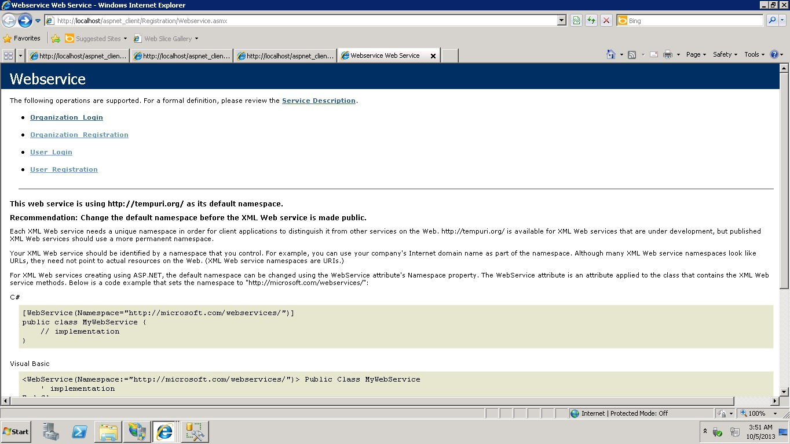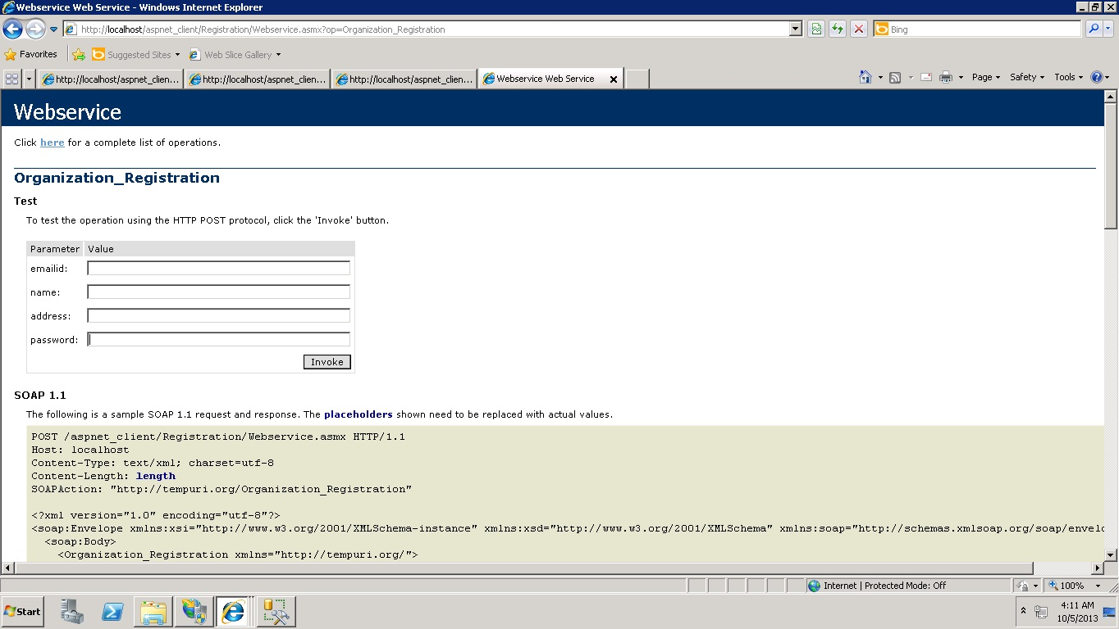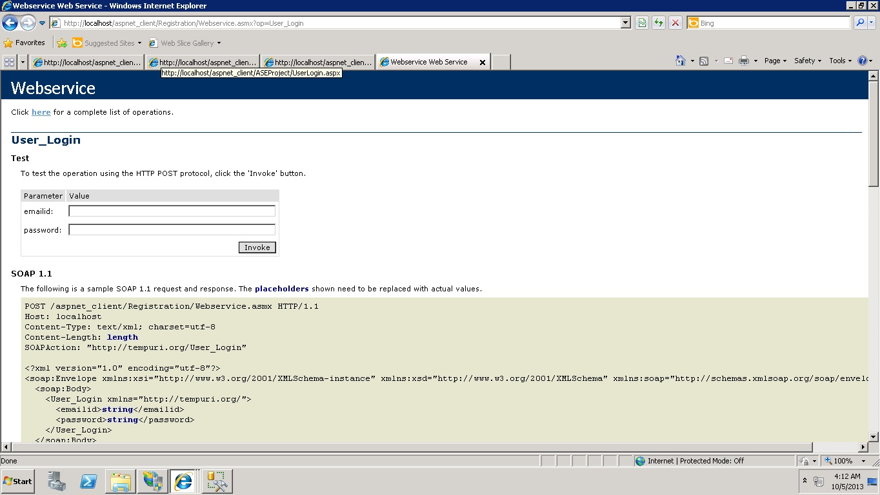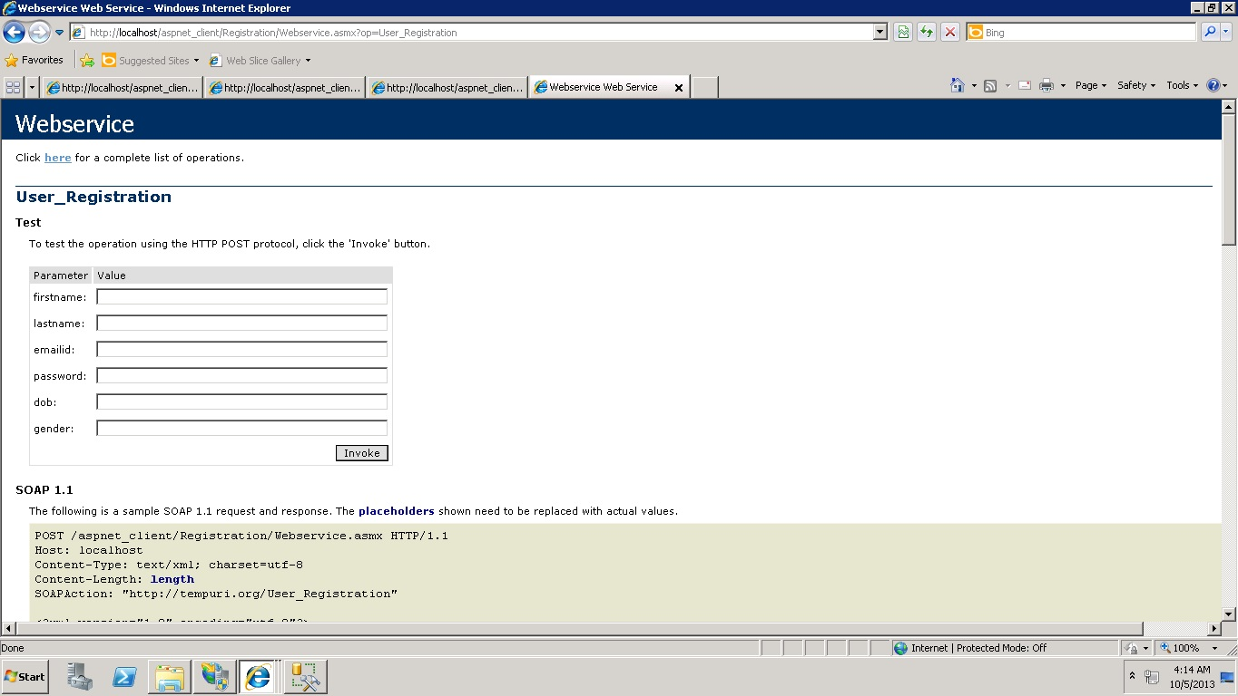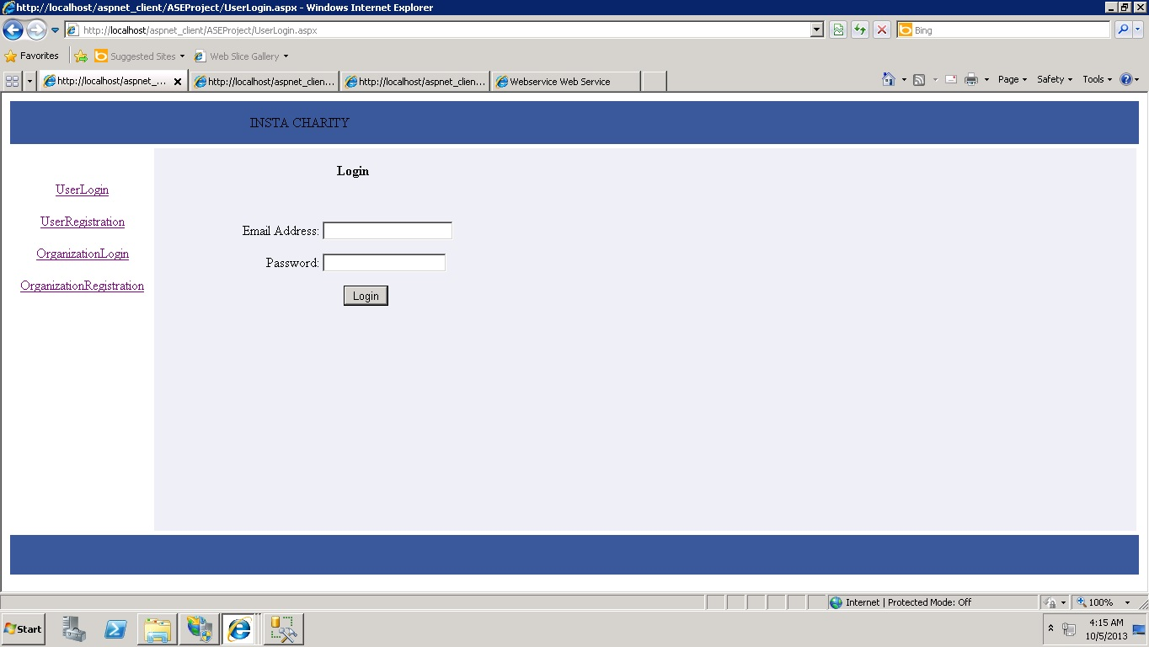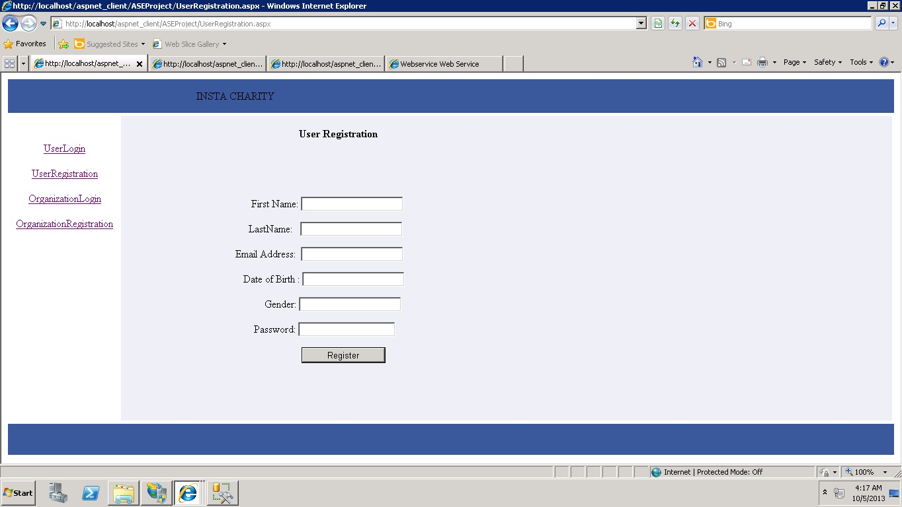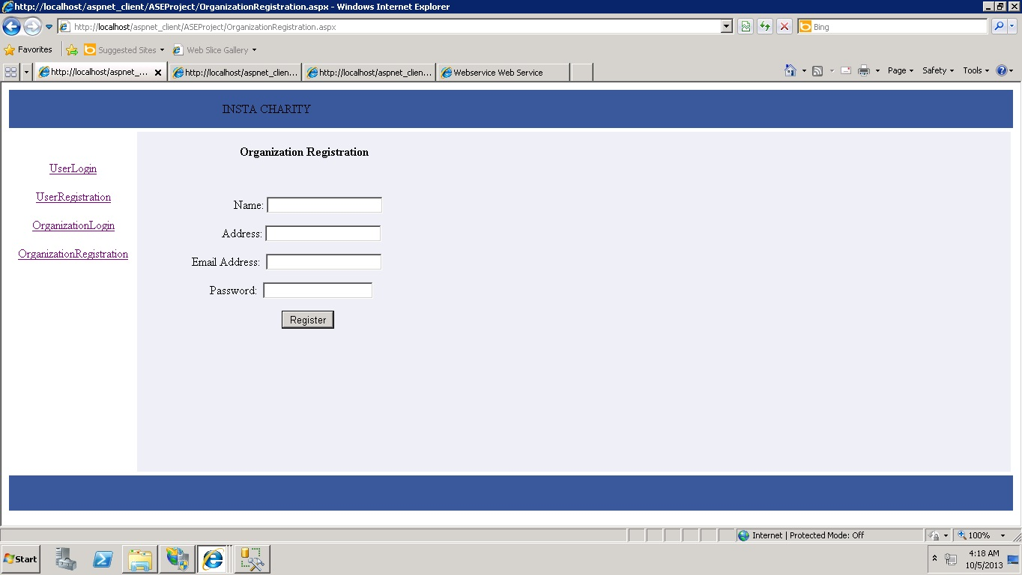

**Deployment:**

**Scrum Do URL:**

<http://www.scrumdo.com/projects/project/insta-charity/iteration/78011>

**Cloud URL:**

<http://vhost1135.site1.compute.ihost.com/aspnet_client/ASEProject/OrganizationLogin.aspx>

**Git hub URL:**

<https://github.com/instacharity/Instacharityproject/tree/master/Increment%201>